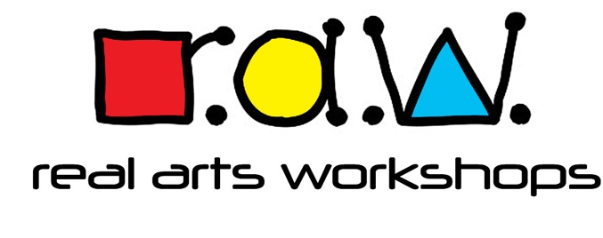
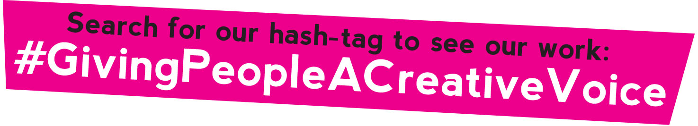

Safer Recruitment Policy
We believe everyone has a responsibility to promote the welfare of all children and vulnerable adults to keep them safe and to practise in a way that protects them.
Therefore, the main principles of our safer recruitment policy are to take all steps necessary to prevent people who might harm children or vulnerable adults from taking up positions where they could do so and to follow all of the latest guidelines and best practices to keep the recruitment process safe, fair and consistent.

In practice this means ensuring that the staff and volunteers who are hired to work with children, young people and vulnerable adults have been suitably checked to prevent any harm being done to the people in their care. We give equal priority to keeping all our participants safe regardless of their age, disability, gender reassignment, race, religion or belief, sex, or sexual orientation

A safeguarding alert is the notification of a concern, allegation or an incident of inappropriate behaviour, such as abuse or neglect, by anyone working with children, young people or vulnerable adults. Anyone can raise an alert, and they will be dealt with swiftly.
To enable this

- We will robustly implement safer recruitment processes
- Identify and reject applicants who are unsuitable to work with children and young people and vulnerable adults
- Respond to concerns about the suitability of employees and volunteers once they have begun their role
- Ensure all new staff and volunteers participate in an induction which includes child protection
- List the supporting procedures that accompany the policy (see below)

All roles, paid and voluntary, will be advertised and will have a Job Description and Person Specification attached.
We will check that applicants have a Right To Work in the UK (in accordance to the latest government list of documents).
We will carry out ID checks – taking copies of one of the original documents:
- Passport
- Driving Licence or
- Recent Utility Bill

We will recruit staff based on the following criteria:
- Skills and experience
- Values, attitudes and behaviours
- Work History
- Qualifications
- References
- Suitability for the role
We will ask candidates to complete a Self-Disclosure Form and will organise Enhanced DBS checks for regulated roles.

This policy should be read alongside these other policies:
- Staff Code of Conduct Policy
- Complaints Procedure
- Equality Diversity and Inclusion Policy
- Safeguarding and Child Protection
- Safeguarding Adults Policy
- Incident Log
- Whistleblowing Policy
- GDPR and Privacy Policy
which are available on our website https://www.realartsworkshops.co.uk/ under “Policies” or the password protected “Staff Area”.
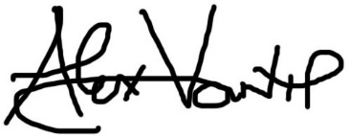
September 2021

