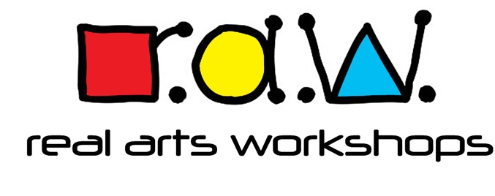
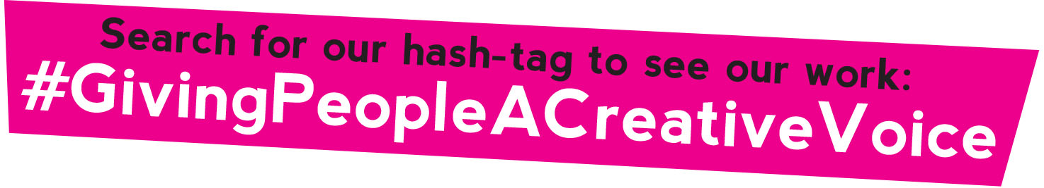

Equality, Diversity & Inclusion Policy
Real Arts Workshops (RAW) is dedicated to encouraging a supportive and inclusive culture amongst the whole workforce. It is within our best interest to promote diversity and eliminate discrimination in the workplace.
Our aim is to ensure that all employees and job applicants are given equal opportunity and that our organisation is representative of all sections of society. Each employee will be respected and valued and able to give their best as a result.
This policy reinforces our commitment to providing equality and fairness to all in our employment and not provide less favourable facilities or treatment on the grounds of age, disability, gender reassignment, marriage and civil partnership, pregnancy and maternity, race, ethnic origin, colour, nationality, national origin, religion or belief, or sex and sexual orientation. We are opposed to all forms of unlawful and unfair discrimination.
All employees, no matter whether they are part-time, full-time, or temporary, will be treated fairly and with respect. When RAW selects candidates for employment, promotion, training, or any other benefit, it will be on the basis of their aptitude and ability.
All employees will be given help and encouragement to develop their full potential and utilise their unique talents. Therefore, the skills and resources of our organisation will be fully utilised and we will maximise the efficiency of our whole workforce.
Real Arts Workshops commitments:
• To create an environment in which individual differences and the contributions of all team members are recognised and valued.
• To create a working environment that promotes dignity and respect for every employee.
• To not tolerate any form of intimidation, bullying, or harassment, and to discipline those that breach this policy.
• To make training, development, and progression opportunities available to all staff.
• To promote equality in the workplace, which [company name] believes is good management practice and makes sound business sense.
• To encourage anyone who feels they have been subject to discrimination to raise their concerns so we can apply corrective measures.
• To encourage employees to treat everyone with dignity and respect.
• To regularly review all our employment practices and procedures so that fairness is maintained at all times.
Real Arts Workshops will inform all employees that an equality and diversity policy is in operation and that they are obligated to comply with its requirements and promote fairness in the workplace. The policy will also be drawn to the attention of funding agencies, stakeholders, customers, learners, and job applicants.
Real Arts Workshops equality and diversity policy is fully supported by senior management and has been agreed with trade unions and/or employee representatives

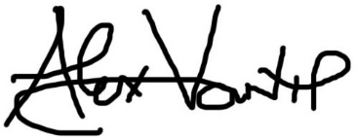

Our policy will be monitored and reviewed annually to ensure that equality and diversity is continually promoted in the workplace.
Date: MARCH 2022

