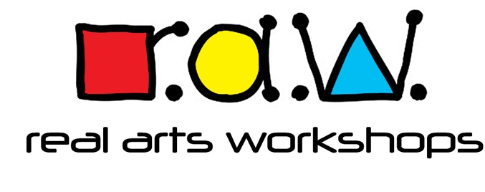
The Studio, 26 Romsey Road, Wolverhampton WV10 6EX
Tel: 07762 213885
Email: realartsworkshops@gmail.com
Web: www.realartsworkshops.co.uk

Cancellations Policy

CANCELLATIONS
Should the [customer] cancel any date(s) and an alternative date(s) cannot be arranged, the following cancellation fee applies:
4 weeks notice 25% of fee
2 weeks notice 50% of fee
Less than 2 week’s notice full fee paid.

We are committed to reviewing our policy and good practice annually. This policy was last reviewed : March 2021
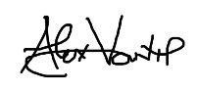
Signed: Date: 30.3.2021

