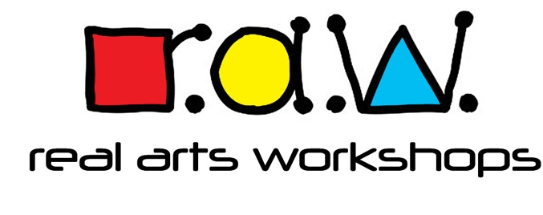

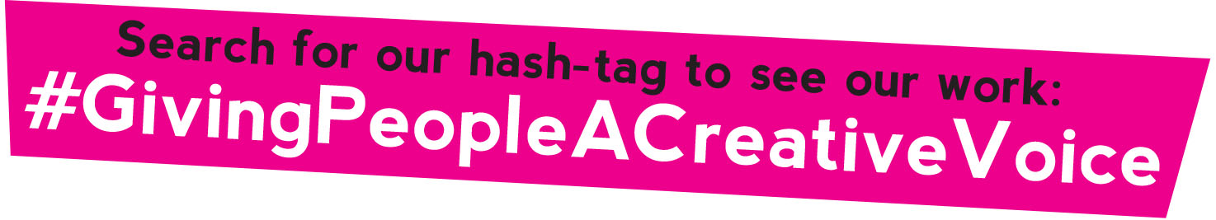

Anti-Bullying Policy

Designated Safe Guarding Lead : Alex Vann
Other Safeguarding Officer: Gary O’Dowd

If another person needs to be contacted other than Alex or Gary the Safeguarding numbers are on the RAW Safeguarding Policy.
Contact information: 07762 213885/ realartsworkshops@gmail.com

Real Arts Workshops (RAW) will:
Recognise its duty of care and responsibility to safeguard all participants from harm.
Promote and implement this anti-bullying policy.
Seek-to ensure that bullying behaviour is not accepted or condoned.
Require all members of RAW be given information about this policy, it will be available in the website.
Take action to investigate and respond to any alleged incidents of bullying.
Encourage and facilitate children and young people to play an active part in developing and adopting a code of conduct to address bullying.
Ensure that staff are given access to information, guidance and/or training on bullying. Each participant, coach, volunteer or official will:

- Respect every child’s need for, and rights to, an environment where safety, security, praise, recognition and opportunity for taking responsibility are available.
- Respect the feelings and views of others.
- Recognise that everyone is important and that our differences make each of us special and should be valued.
- Show appreciation of others by acknowledging individual qualities, contributions and progress.
- Be committed to the early identification of bullying, and prompt and collective action to deal with it
- Ensure safety by having rules and practices carefully explained and available for all to see.
- Report incidents of bullying they see – by doing nothing you are condoning bullying.

Bullying
All forms of bullying will be addressed.
Everybody in the organisation has a responsibility to work together to stop bullying.
Bullying can include online as well as offline behaviour.
Bullying can include:
- physical pushing, kicking, hitting, pinching etc.
- name calling, sarcasm, spreading rumours, persistent teasing and emotional torment through ridicule, humiliation or the continual ignoring of individuals.
- posting of derogatory or abusive comments, videos or images on social network sites
- racial taunts, graffiti, gestures, sectarianism

- sexual comments, suggestions or behaviour
- unwanted physical contact

Children with a disability, from ethnic minorities, young people who are gay, lesbian or trans, or those with learning disabilities are more vulnerable to this form of abuse and are more likely to be targeted.

Support for the child:
Children should know who will listen to and support them.
Systems should be established to open the door to children wishing to talk about bullying or any other issue that effect them.
Potential barriers to talking (including those associated with a child’s disability or impairment) need to be identified and addressed at the outset to enable children to approach adults for help.

Children should have access to Helpline numbers.
Anyone who reports an incident of bullying will be listened to carefully and be supported.
Any reported incident of bullying will be investigated objectively and will involve listening carefully to all those involved.
Children being bullied will be supported and assistance given to uphold their right to play and live in a safe environment which allows their healthy development.
Those who bully will be supported and encouraged to stop bullying.
Sanctions for those bullying others that involve long periods of isolation, or which diminish and make
individuals look or feel foolish in front of others, will be avoided.

Support for the parents/guardians
Any incident of bullying will be discussed with the child’s parent(s)/guardians.
Parents will be consulted on action to be taken (for both victim and bully) and agreements made as to what action should be taken.
Information and advice on coping with bullying will be made available.
Support should be offered to the parent(s) including information on other agencies or support lines.

Useful contacts:

NSPCC Helpline 0808 800 5000 https://www.nspcc.org.uk/
ChildLine 0800 1111 / www.childline.org.uk
Kidscape www.kidscape.org.uk
Anti-Bullying Alliance https://www.anti-bullyingalliance.org.uk/

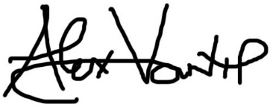

March 2021

