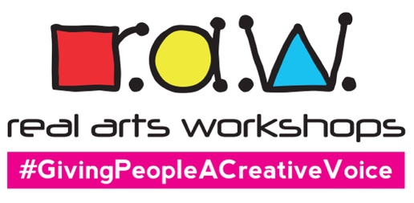

REAL ARTS WORKSHOPS LTD
The Studio, 26 Romsey Road, Wolverhampton WV10 6EX
Tel: 07882 685923
Email: realartsworkshops@gmail.com
Web: www.realartsworkshops.co.uk

Job Description
Arts Workshop Facilitator (Freelance Staff Pool)

ABOUT US
Real Arts Workshops (RAW) is an innovative creative workshops company based in Wolverhampton in the West Midlands. We use various artforms to enable individuals and groups to actively engage with art.
Our customers include individuals and groups who may have previously experienced barriers to the Arts and include young people, people with disabilities, mental health issues, neurodiverse people, those with behavioural issues, the elderly, and so on.

Typical responsibilities include:
- Teaching creative skills to project participants
- Admin and project management
- Leading workshops
- Offering guidance and support to people
- Maintaining a safe environment
- Organising art materials at the start and end of sessions
- General housekeeping: tidying, washing paintbrushes etc

ABOUT YOU
You will probably have experience of making or leading visual art, crafts, music, creative writing, or BSL (British Sign Language) activities and would like the opportunity to work with young people, the elderly, people with disabilities, Deaf people and getting involved in interesting Arts projects, both Community-based and Corporate.

You will have:
- Experience of facilitating art workshops
- Your own tax responsibilities as a freelancer / company
- Great communication skills
- Compassion and patience
- Experience of working on you own initiative
- A strong work ethic
- Teamworking approach
- A good sense of humour
- Good time management
- An understanding of basic legal responsibilities of this sort of work

We can offer:
- A fun working environment
- Basic BSL (British Sign Language) and Deaf awareness teaching
(don’t worry if you’ve never done this before)
- Learning new art skills and techniques
- The opportunity to work with diverse groups of people
- Working as part of a fun, energised team
- Training courses
- DBS certificates if necessary (existing portable DBS preferred)
- Access to our passworded Staff Area on the RAW website with various policies and procedures
- A RAW branded T-Shirt for regular workers

How to apply:
If you are interested, please complete and return the FREELANCE ARTIST/SUPPLIER FORM to realartsworkshops@gmail.com with a copy of your Current CV if you have one.

Please cover the following points:

- Skills and experience
- Values, attitudes and behaviours
- Work History
- Qualifications
- References
- Suitability for the role
And, as we work with children and vulnerable people, you will need to complete a separate Self-Disclosure Form at the point of engagement.

Thank you

