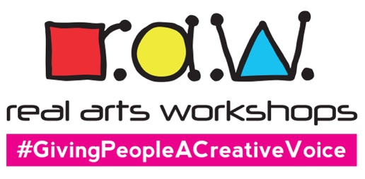

REAL ARTS WORKSHOPS LTD
The Studio, 26 Romsey Road, Wolverhampton WV10 6EX
Tel: 07882 685923
Email: realartsworkshops@gmail.com
Web: www.realartsworkshops.co.uk

Creative Workshops Volunteer

ABOUT US
Real Arts Workshops (RAW) is an innovative creative workshops company based in Wolverhampton in the West Midlands. We use various artforms to enable individuals and groups to actively engage with art.
Our customers include individuals and groups who may have previously experienced barriers to the Arts. Our audiences include young people, people with disabilities, mental health issues, neurodiverse people, those with behavioural issues, the elderly, and so on.

We are looking for a volunteer to join us at RAW that will enjoy getting involved with creative projects such as arts, crafts and music. This would be an ideal opportunity for those seeking to gain experience working with people from all ages and backgrounds including people living with disabilities and mental health illnesses.

What you will be helping with:
- Help participants develop their creative skills
- Ensure a safe and fun environment at all times
- Support with organising materials before sessions
- Tidying up after sessions e.g., washing paintbrushes etc

The idea volunteer will:
- Have good communications skills and show compassion
- Enjoy working within a team
- Have good time management skills

What we can offer:
- Basic BSL (British Sign Language) and Deaf awareness training
- Support in developing art skills and techniques
- The opportunity to work with a diverse group of people and within a fun team
- DBS (Disclosure & Barring Service) certificate (if you don’t already have one)

If you are interested, please send your completed Volunteer Application Form to realartsworkshops@gmail.com with a copy of your current CV if you have including any relevant experience and skills.

As we work with children and vulnerable people, you will be asked to complete a Self-Disclosure Form before doing any volunteering with us.

